SOP – Python Poetry Project and Dependency Management

1. Document Information
Field | Details
Document Name | SOP – Python Poetry Project and Dependency Management
Tool | Poetry
Technology | Python
Environment | Ubuntu Linux
Purpose | Python project creation, dependency management, virtual environment management and command execution
Audience | Developers / DevOps Engineers
Review | Pre / L0 Reviewer

2. Objective
The objective of this SOP is to define the standard procedure for using Poetry to create and manage Python projects.
This SOP covers:
- Poetry installation and verification
- Creating a new Python project
- Understanding project structure
- Managing the Poetry virtual environment
- Adding and removing dependencies
- Installing dependencies
- Understanding pyproject.toml
- Understanding poetry.lock
- Running Python commands using Poetry
- Running a Python application
- Running tests
- Verifying the project environment

3. Prerequisites
The following prerequisites are required:
- Ubuntu/Linux system
- Python 3 installed
- pip installed
- Internet connectivity
- Terminal access
- Basic Python knowledge

4. Verify Python Installation

Purpose
Verify that Python 3 is installed before using Poetry.

Command
python3 –version
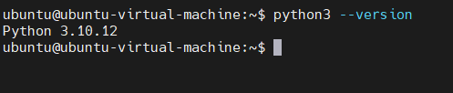

5. Verify pip Installation

Purpose
Verify that the Python package installer is available.

Command
pip3 --version
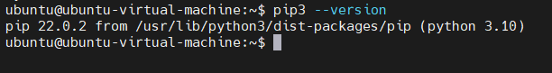

6. Install Poetry

Purpose
Install Poetry if it is not already available on the system.

Command
curl -sSL https://install.python-poetry.org | python3 –
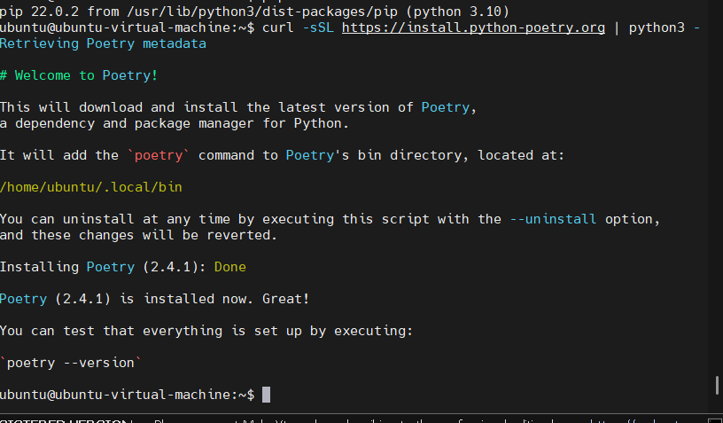

7. Create a New Poetry Project

Purpose
Create a new Python project using Poetry.
Create the project:
poetry new poetry-demo
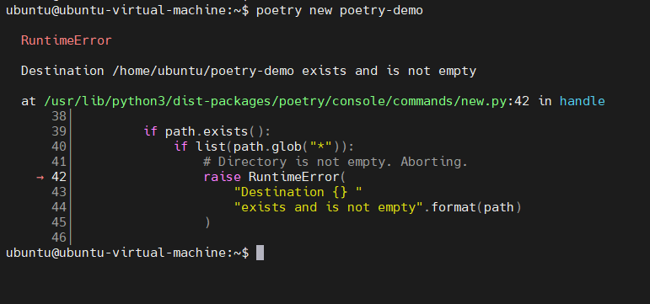
Enter the project:
cd poetry-demo
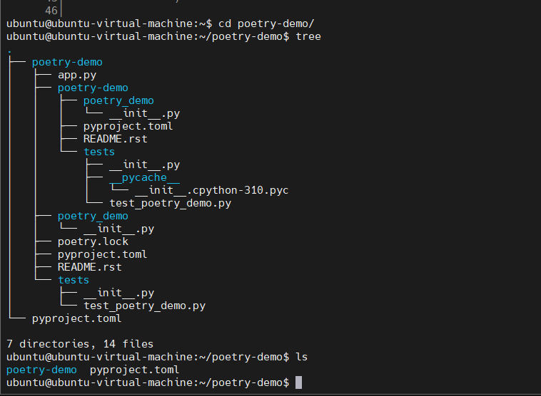

8. Verify Project Structure

Purpose
Verify the files and directories created by Poetry.

Expected Result
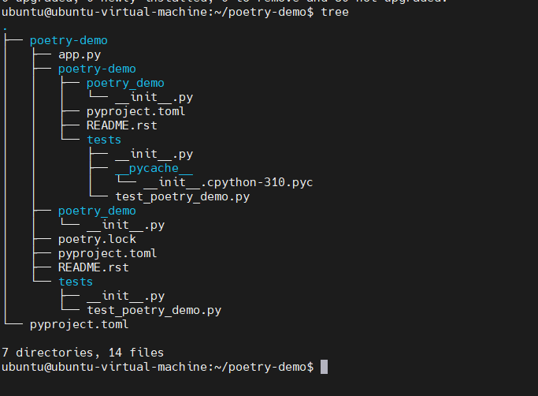

9. Understand pyproject.toml

Purpose
pyproject.toml contains the project’s configuration and dependency information.

Command
cat pyproject.toml

Expected Result
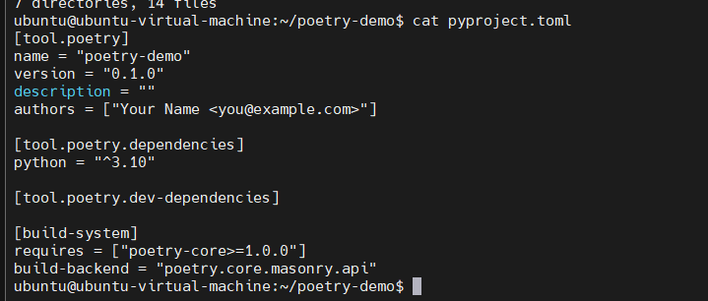
The file should contain project information such as:
- Project name
- Version
- Python requirement
- Dependencies
- Build configuration

10. Check Poetry Environment

Purpose
Check information about the virtual environment used by Poetry.

Command
poetry env info

Expected Result
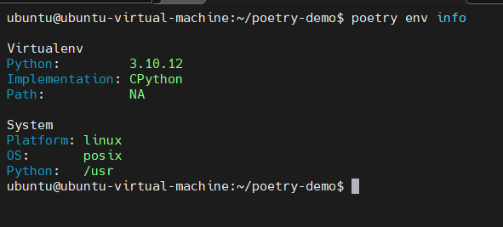
Poetry should display information about:
- Python version
- Virtual environment
- Environment path
- Executable
- Validity

11. Check Virtual Environment Path

Purpose
Identify where Poetry has created the project’s virtual environment.

Command
poetry env info –path
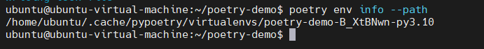

12. Install Project Dependencies

Purpose
Install all dependencies defined for the project.

Command
poetry install

Expected Result if already installed
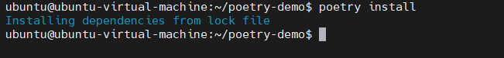

13. Add a Python Dependency

Purpose
Add a third-party Python package to the project.
For demonstration, use the requests package.

Command
poetry add requests

Expected Result
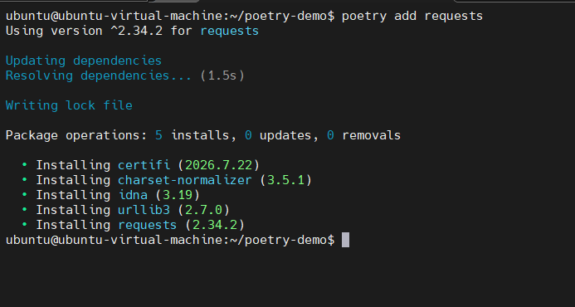

14. Verify Installed Dependencies

Purpose
Verify that the dependency was installed successfully.

Command
poetry show

Expected Result
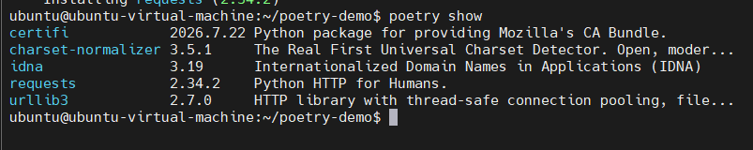

15. Verify a Specific Dependency

Purpose
Check details of a particular package.

Command
poetry show requests

Expected Result
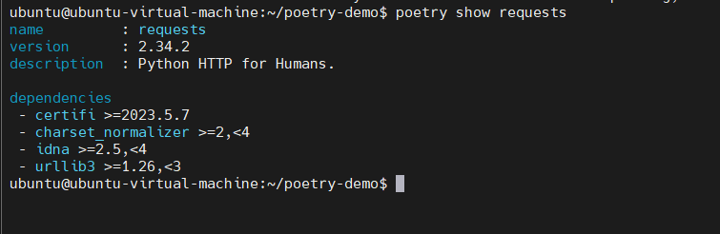

16. Verify pyproject.toml After Adding Dependency

Purpose
Verify that Poetry has added the dependency to the project configuration.

Command
cat pyproject.toml

Expected Result
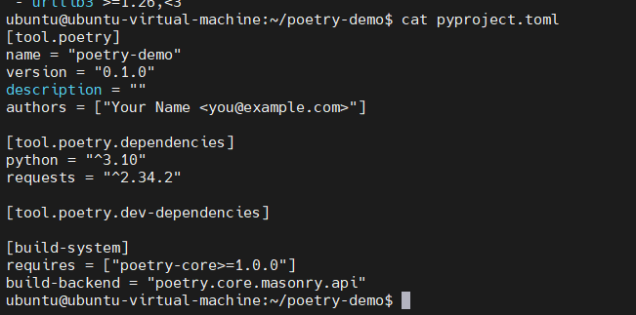

17. Verify poetry.lock

Purpose
Verify that Poetry has created/updated the lock file.

Command
ls -l poetry.lock

Expected Result
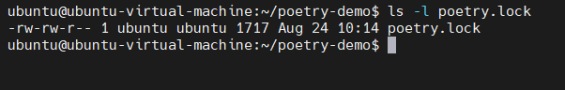
You can also check:
head -30 poetry.lock
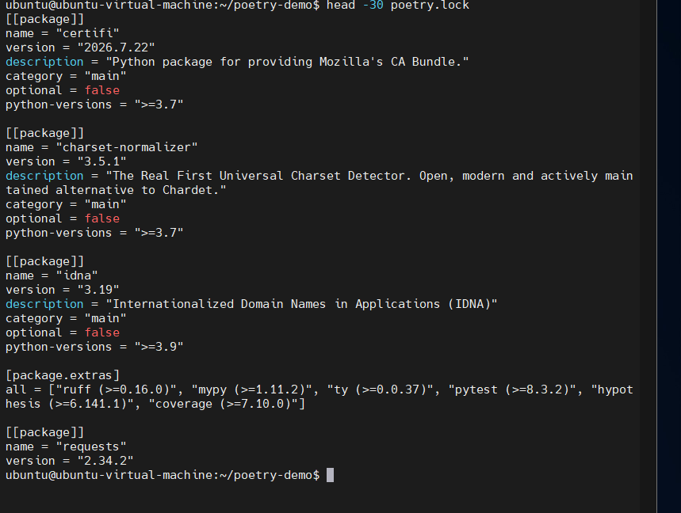

18. Run Python Using Poetry

Purpose
Run Python commands using the Poetry-managed environment.

Command
poetry run python --version

Expected Result
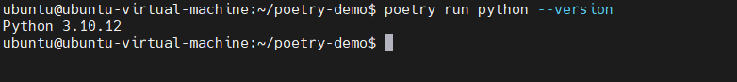

19. Verify Dependency Inside Poetry Environment

Purpose
Verify that the installed dependency is available inside the Poetry environment.

Command
poetry run python -c "import requests; print(requests.__version__)"

Expected Result
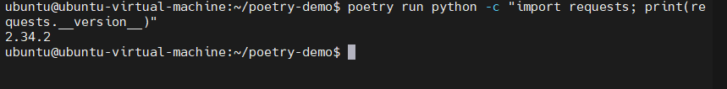

20. Create a Python Application

Purpose
Create a simple Python application that uses the Poetry-managed dependency.

Command
nano app.py
Add the following code:
import requests
response = requests.get("https://example.com")
print("Status Code:", response.status_code)
Save the file.
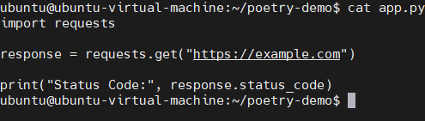

21. Run the Python Application

Purpose
Execute the application using the Poetry environment.

Command
poetry run python app.py

Expected Result
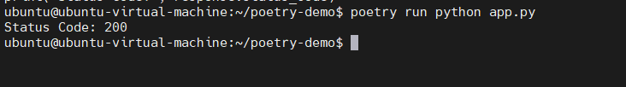

22. Run Commands in Poetry Context

Purpose
Demonstrate that commands can be executed inside the project’s Poetry environment without manually activating the environment.

Commands
Check Python:
poetry run python –version
Check installed packages:
poetry run pip list
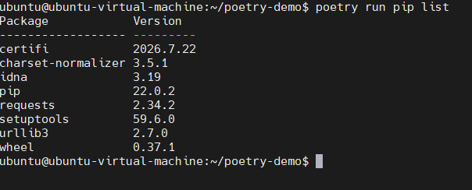
Run the application:
poetry run python app.py

Expected Result

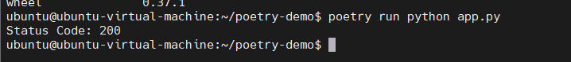

23. Remove a Dependency

Purpose
Remove a dependency from the project.

Command
poetry remove requests

Expected Result
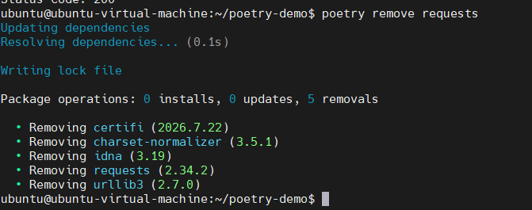

24. Verify Dependency Removal

Command
poetry show
Or:
poetry show requests

Expected Result
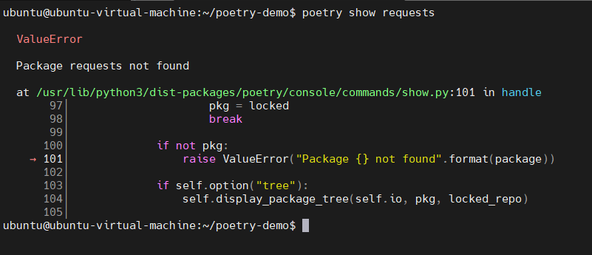

25. Run Project Validation

Purpose
Check whether the Poetry project configuration is valid.

Command
poetry check

Expected Result
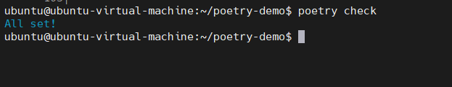

26. Common Poetry Commands
Command | Purpose
poetry --version | Check Poetry version
poetry new project-name | Create a new project
poetry init | Initialize Poetry in an existing project
poetry install | Install project dependencies
poetry add package | Add dependency
poetry remove package | Remove dependency
poetry show | Display installed packages
poetry update | Update dependencies
poetry env info | Display environment information
poetry env info --path | Display environment path
poetry run command | Run command inside Poetry environment
poetry check | Validate project configuration

27. Troubleshooting

Issue 1: poetry: command not found
Check whether Poetry is in PATH:
echo $PATH
Try:
export PATH="$HOME/.local/bin:$PATH"
Then:
poetry –version
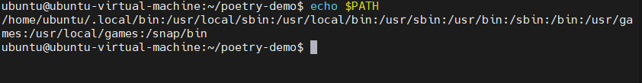
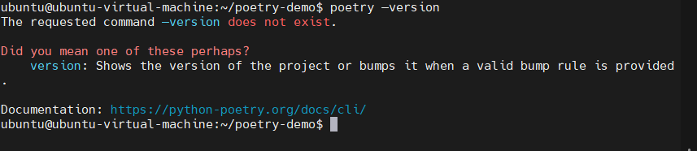

Issue 2: ModuleNotFoundError
Example:
ModuleNotFoundError: No module named 'requests'
Install the dependency:
poetry add requests
Then run:
poetry run python app.py
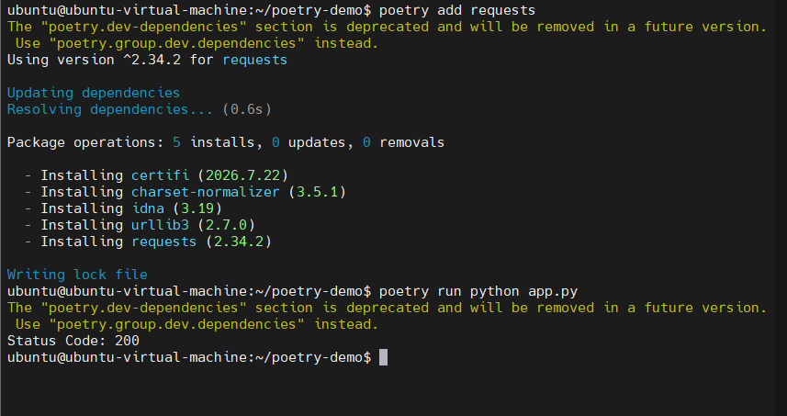

Issue 3: Python Syntax Error
Check the Python file:
cat app.py
Make sure the code is correct.
Then run:
poetry run python app.py
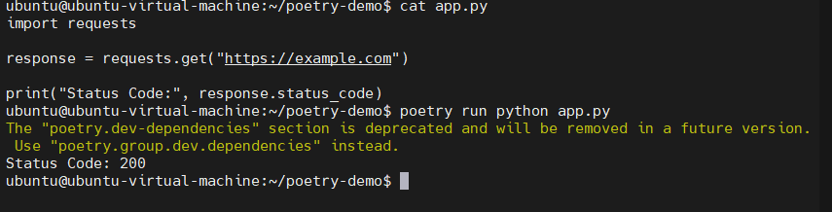

28. Recommended Demo for Pre/L0 Reviewer
During the review, demonstrate the following workflow:
Verify Python
↓
Verify Poetry
↓
Create Project
↓
Show Project Structure
↓
Show pyproject.toml
↓
Check Virtual Environment
↓
Install Dependencies
↓
Add requests
↓
Show poetry.lock
↓
Run Python using poetry run
↓
Run Application
↓
Verify Result

Live Demo Commands
python3 --version
poetry --version
cd ~
poetry new poetry-demo
cd poetry-demo
tree
cat pyproject.toml
poetry env info
poetry env info --path
poetry install
poetry add requests
poetry show
poetry run python --version
poetry run python -c "import requests; print(requests.__version__)"
nano app.py
cat app.py
poetry run python app.py
poetry check

29. Expected Final Project Structure
After completing the SOP, the project should look similar to:
poetry-demo/
├── README.md
├── app.py
├── poetry.lock
├── pyproject.toml
├── poetry_demo/
│ └── __init__.py
└── tests/
└── __init__.py

30. Screenshot Checklist
Capture screenshots for the following important steps:
- Python version
- Poetry version
- Project creation
- Project structure
- pyproject.toml
- Poetry environment information
- Environment path
- poetry install
- poetry add requests
- poetry show
- poetry.lock
- poetry run python --version
- requests verification
- app.py
- Successful application execution
- poetry check

31. Conclusion
Poetry provides a standardized way to manage Python projects, dependencies, virtual environments and project execution.
Using Poetry provides better dependency management and reproducibility compared with manually installing packages for each project.
The key files are:
pyproject.toml
↓
Project configuration + dependencies
poetry.lock
↓
Locked/resolved dependency versions
The key command for running the project is:
poetry run python app.py
The overall workflow is:
Create
↓
Configure
↓
Install
↓
Add Dependencies
↓
Lock Dependencies
↓
Run
↓
Test
↓
Deploy

